**Individual Exam 3**

EPID600: Principles of Epidemiology for Public Health

**Grading Rubric**

|  |  |  |
| --- | --- | --- |
| **Exam sections** | **Points** | **Score** |
| PART 1. UNC25 Virus and Cancer and Systematic Error |  |  |
| Questions 1-14, excluding calculation tables, 4pts each | 46 |  |
| Tables 1,3,4 calculation tables | 18 |  |
| PART 2. Comprehensive Review & Integration |  |  |
| Questions 15-30, 4pts each | 60 |  |
| Total points | 128 |  |

*Please paste your answers to questions 1-30 on the answer sheet below. Use short 1-2 sentence answers for your written responses. Once you’ve completed the exam, upload your answer sheet. For partial credit on your data analysis questions, include your data analysis output and calculations in an appendix, after the answer sheet. Remember to follow the honor code in completing this exam. If you have questions, please seek clarification from either Prof. Yeatts, Rebecca Bloch, or Amber Hall.*

**Individual Exam 3 Answer Sheet. Please fill your exam answers here.**

2. DAG1
   1. Age
   2. Sex
   3. Decreased immune status
3. DAG2
   1. Age
   2. Sex
   3. Education
4. Table

|  |  |  |
| --- | --- | --- |
| Table 1. Crude and Sex Stratum-specific Odds Ratio between UNC 25 Virus Exposure and Cancer Diagnosis | | |
| *Measure* | *Estimate* | *95% CI* | |
| *Crude OR* | *4.22* | *1.75 – 10.18* | |
| *Stratum-specific OR* |  |  | |
| *Male* | *2.40* | *.76-7.93* | |
| *Female* | *7.50* | *1.97-28.61* | |

1. Table 2 Interpretation
2. Table 2 Interpretation
3. Table 2 related Interpretation
4. Table 2 related Interpretation
5. Complete Table 3

|  |  |  |
| --- | --- | --- |
| Table 3.Comparison of Unadjusted OR and Sex-adjusted OR with 95%CIs. | | |
| *Measure* | *Estimate* | *95% CI* |
| *Crude OR* | *4.22* | *1.75-10.18* |
| *Sex-adjusted OR* | *(2)* | *(2)* |
| *% difference* | *(2)* |  |

1. Interpret
2. Complete Table 4

|  |  |  |
| --- | --- | --- |
| Table 4.Comparison of Race-adjusted and Unadjusted OR with 95%CIs and p-values using Logistic Regression | | |
| *Measure* | *Estimate* | *95% CI* |
| *Crude OR* | *4.22* | *1.75-10.18* |
| *Race-adjusted OR* | *(2)* | *(2)* |
| *% difference* | *(2)* |  |

1. Interpretation
2. Briefly summarize

PART 2. Comprehensive Review and Integration



PART 1. UNC25 Virus and Cancer and Systematic Error

Use the data set from Exams 1&2. For calculations, revisit your work from your confounding labs.

1. **If this study were a “regular” case control study and not a nested case control, describe a scenario in which selection bias might affect your study.**

Selection bias could occur in a regular case-control study that a nested case control study would be able to prevent. If the cases or controls were selected differentially on the basis of their exposure status (UNC25 Virus), this could affect the study. Since both the exposure, UNC25 Virus and the disease, cancer have occurred by the time the patient is recruited into the study this would be a significant possibility in a regular case-control study.

1. **Do you think, given the nested case control aspect of the study, that there would be selection bias? Explain why or why not.**

The selection bias of the nested case control is dependent on how biased the cohort is, thus it will not introduce any additional selection bias into the study.

1. **DAG1, Figure 1: In your literature review on UNC 25 virus and cancer, you came across the DAG below which illustrates how a research team conceptualized the relationship between UNC25 virus and cancer. Identify each variable as either a confounder, mediator, or modifier or none of these options.**
   1. **Age** confounder
   2. **Sex** confounder
   3. **Depressed immune status** mediator

Figure 1. Directed Acyclic Graph for UNC25 virus and Cancer.

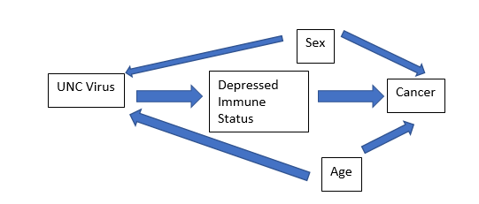

UNC 25

1. **DAG2, Figure 2: In your literature review on UNC 25 virus and cancer, you came across a different DAG, below, which illustrates how a research team conceptualized the relationship between UNC25 virus and cancer with respect to age, and sex. Identify each variable as either a confounder, mediator, or modifier, or none of these options.**
   1. **Sex** confounder
   2. **Age** modifier
   3. **Education** none of these

Figure 2. Directed Acyclic Graph for UNC25 virus and Cancer.

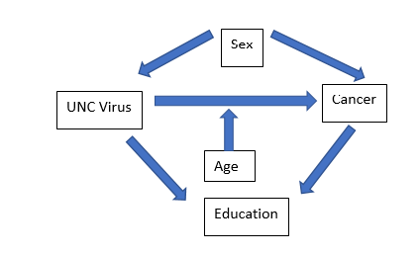

UNC 25

1. **Assess confounding by sex (dichotomized variable) using the stratification approach**. **Insert your calculated odds ratios and 95%CIs to Table 1 below.**

|  |  |  |
| --- | --- | --- |
| Table 1. Crude and Sex Stratum-specific Odds Ratio between UNC 25 Virus Exposure and Cancer Diagnosis | | |
| *Measure* | *Estimate* | *95% CI* | |
| *Crude OR* | *4.22* | *1.75 – 10.18* | |
| *Stratum-specific OR* |  |  | |
| *Male* | *2.40* | *.76-7.93* | |
| *Female* | *7.50* | *1.97-28.61* | |

1. **Consider results from your colleague’s publication below in Table 2. Compare the stratified OR estimates to a non stratified (crude) OR estimate in Table 2 below.**

The odds of being diagnosed with cancer is 5.8 times higher for people exposed to the UNC25 virus compared to people not exposed to the UNC25 virus. The 95% CI is (1.32-12.39), this tell us that 95% of the time, when we calculate a confidence interval in this way, the true parameter will be between the two values.

The odds of being diagnosed with cancer for people Males is 1.50 times higher for people exposed to the UNC25 virus compared to people not exposed to the UNC25 virus. The 95% CI is (0.5,8.75), this tell us that 95% of the time, when we calculate a confidence interval in this way, the true parameter will be between the two values.

The odds of being diagnosed with cancer Females is 9.20 times higher for people exposed to the UNC25 virus compared to people not exposed to the UNC25 virus. The 95% CI is (2.48,33.80), this tell us that 95% of the time, when we calculate a confidence interval in this way, the true parameter will be between the two values.

The sex-stratified OR estimate for females is much larger than the crude unadjusted OR estimate. The sex-stratified OR estimate for males is much smaller than the crude unadjusted OR estimate. This would flag that there is evidence that confounding by dichotomized sex is present.

By looking at the odds ratio confidence intervals, the crude OR 95% CI and the sex-stratified OR CI for males are the most precise compared the one for females. (since the range of these two are the narrowest). The largest confidence interval by far is for the Female stratum Odds Ratio.

|  |  |  |
| --- | --- | --- |
| Table 2. Crude and Sex Stratum-specific Odds Ratio between UNC 25 Virus Exposure and Cancer Diagnosis | | |
| *Measure* | *Estimate* | *95% CI* | |
| *Crude OR* | 5.8 | 1.32 – 12.39 | |
| *Stratum-specific OR* |  |  | |
| *Male* | 1.5 | 0.50 – 8.75 | |
| *Female* | 9.2 | 2.48 – 33.80 | |

1. **Which pattern from the stratification diagram do your results resemble? Refer to Table 2**
2. **Describe the pattern. Is there evidence of confounding or EMM by sex? Refer to Table 2**
3. **Interpret and comment on the confidence intervals. Refer toTable 2**

1. **Assess confounding by sex using the *modeling* technique.** **Fill in table 3.**

|  |  |  |
| --- | --- | --- |
| Table 3.Comparison of Unadjusted OR and Sex-adjusted OR with 95%CIs. | | |
| *Measure* | *Estimate* | *95% CI* |
| *Crude OR* | *4.22* | *1.75-10.18* |
| *Sex-adjusted OR* | *4.13* | *1.75-10.39* |
| *% difference* | *2%* |  |

1. **Interpret the results from your table. Compare the unadjusted, adjusted OR and interpret the percent difference. Is there evidence of confounding? Explain.**

The odds of being diagnosed with cancer is 4.22 times higher for people exposed to the UNC25 virus compared to people not exposed to the UNC25 virus.

The odds of being diagnosed with cancer is 4.13 times higher for people exposed to the UNC25 virus compared to people not exposed to the UNC25 virus when adjusting for Sex.

The odds ratio decreases by 2% when adjusted for Sex. By looking at the difference between the odds ratio, it is unlikely Sex is a confounder (the general cut off is usually greater than 10%).

1. **Assess race as a potential confounder using the modeling approach.** **Fill in table 4 below.**

|  |  |  |
| --- | --- | --- |
| Table 4.Comparison of Race-adjusted and Unadjusted OR with 95%CIs and p-values using Logistic Regression | | |
| *Measure* | *Estimate* | *95% CI* |
| *Crude OR* | *4.22* | *1.75-10.18* |
| *Race-adjusted OR* | *3.67* | *1.51-9.37* |
| *% difference* | *13%* |  |
|  |  |  |

1. **Interpret the results from your table. Compare the unadjusted, adjusted OR and interpret the percent difference. Is there evidence of confounding? Explain.**

The odds of being diagnosed with cancer is 4.22 times higher for people exposed to the UNC25 virus compared to people not exposed to the UNC25 virus.

The odds of being diagnosed with cancer is 3.67 times higher for people exposed to the UNC25 virus compared to people not exposed to the UNC25 virus when adjusting for Race.

The odds ratio increases by 13% when adjusted for Race. Since the percent difference is 13%, it would indicate there is evidence of confounding for Race

1. **Based on your data analysis, briefly summarize the relationship between exposure to UNC25 and cancer diagnosis**, **potential confounders and effect measure modifiers.**

PART 2. Comprehensive Review and Integration

1. **New Zealand recently changed its gun laws in response to the Christchurch shootings in March 2019. Describe a study that would evaluate the effect of the gun law change. What would be the unit of measure of your exposure and outcome?**

Time Trend Ecological Study. Unit of measurement: total guns

1. **In Figure 1B, what key assumption do Achakulwisut et. al 2019 make about their asthma rate calculations? (not standardization.) How is this different from how we define rates in this course?**

They are weighted by country population, not standardized to the at-risk population.

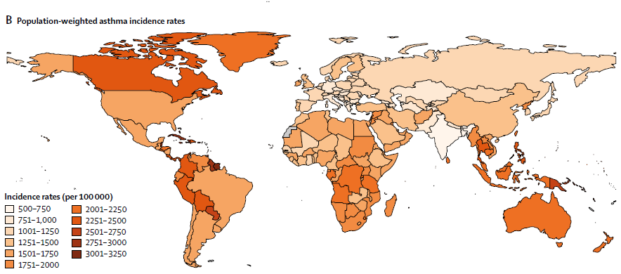

1. **In the abstract by Esser et al. 2019 “Post traumatic stress among cancer patients” (below), what terminology error can you find?**

Prevalence is not a rate, it is a proportion. It is the number of people with the outcome at a given time.

Psychooncology. 2019 Apr 4. doi: 10.1002/pon.5079. Posttraumatic Stress Disorder among cancer patients - Findings from a large and representative interview-based study in Germany.

Esser P1, Glaesmer H1, Faller H2, Koch U3, Härter M4, Schulz H4, Wegscheider K5, Weis J6, Mehnert A1.

OBJECTIVE: In order to optimize psycho-oncologic care for patients with severe stressor-related symptomatology, we aimed to provide (i) valid and generalizable prevalence rates of Posttraumatic Stress Disorder (PTSD) in oncological patients and (ii) the percentage of PTSD cases elicited by cancer-related events.

METHODS: This multi-center study was based on a representative sample of patients across cancer types. A diagnostic interview (CIDI-O) was used to assess PTSD according to DSM-IV. We first describe type and frequency of potentially traumatic events (A1 events) and the degree to which they meet the trauma criteria (A2-events). Subsequently, we present adjusted prevalence rates of PTSD and explore the proportion of patients with cancer-related PTSD.

RESULTS: 4020 patients participated (response rate: 68 %), and 2141 completed the diagnostic interview. 1641 patients reported at least one A1-event, of whom 16 % (n = 257) reported cancer-related events. 91 % (n = 232) of theses cancer-related events qualified as A2-events. Across cancer types, the adjusted 4-week prevalence of PTSD was 2.0 % [95 %-CI: 1.5-2.7]. 9 % (n = 5) of the 4-week PTSD cases were cancer-related.

CONCLUSIONS: Across cancer types and treatment settings, few cancer patients fulfilled diagnostic criteria for PTSD. Of those, a mere fraction was attributable to cancer-related events. These robust findings should be taken into account in both research and practice to develop and provide adequate care for cancer patients with severe stressor-related symptomatology.

1. **What kind of study design do you think Esser et al. 2019 “Post traumatic stress among cancer patients” used? Provide a rationale for your selection, using only the abstract.**

Most likely a cross sectional study since they are taking a snapshot of a population at a certain time, and generalizing the results to a larger population.

1. **Select the Bradford Hill Criteria addressed in the follow systematic review by Loxham et. al 2019 on the health effects of particles in underground railway systems.**

Consistency, Specificity, Strength of Association

Loxham M , Nieuwenhuijsen MJ Health effects of particulate matter air pollution in underground railway systems - a critical review of the evidence. Part Fibre Toxicol. 2019 Mar 6;16(1):12.

BACKGROUND:

Exposure to ambient airborne particulate matter is a major risk factor for mortality and morbidity, associated with asthma, lung cancer, heart disease, myocardial infarction, and stroke, and more recently type 2 diabetes, dementia and loss of cognitive function. Less is understood about differential effects of particulate matter from different sources. Underground railways are used by millions of people on a daily basis in many cities. Poor air exchange with the outside environment means that underground railways often have an unusually high concentration of airborne particulate matter, while a high degree of railway-associated mechanical activity produces particulate matter which is physicochemically highly distinct from ambient particulate matter. The implications of this for the health of exposed commuters and employees is unclear.

MAIN BODY:A literature search found 27 publications directly assessing the potential health effects of underground particulate matter, including in vivo exposure studies, in vitro toxicology studies, and studies of particulate matter which might be similar to that found in underground railways. The methodology, findings, and conclusions of these studies were reviewed in depth, along with further publications directly relevant to the initial search results. In vitro studies suggest that underground particulate matter may be more toxic than exposure to ambient/urban particulate matter, especially in terms of endpoints related to reactive oxygen species generation and oxidative stress. This appears to be predominantly a result of the metal-rich nature of underground particulate matter, which is suggestive of increased health risks. However, while there are measureable effects on a variety of endpoints following exposure in vivo, there is a lack of evidence for these effects being clinically significant as may be implied by the in vitro evidence.

CONCLUSION: There is little direct evidence that underground railway particulate matter exposure is more harmful than ambient particulate matter exposure. This may be due to disparities between in vivo exposures and in vitro models, and differences in exposure doses, as well as statistical under powering of in vivo studies of chronic exposure. Future research should focus on outcomes of chronic in vivo exposure, as well as further work to understand mechanisms and potential biomarkers of exposure.

1. **In Su et al 2019, what type of systematic error are these authors avoiding by using satellite data, rather than self-report to estimate individual level exposure to green space? Choose one of the following: Confounding, Information Bias, Selection Bias.**

Information Bias

Su JG, Dadvand P, Nieuwenhuijsen MJ, Bartoll X, Jerrett M. Associations of green space metrics with health and behavior outcomes at different buffer sizes and remote sensing sensor resolutions Environ Int. 2019 May;126:162-170.

Satellite data is increasingly used to characterize green space for health outcome studies. Literature suggests that green space within 500 m of home is often used to represent neighborhood suitable for walking, air pollution and noise reduction, and natural healing. In this paper, we used satellite data of different spatial resolutions to derive normalized difference vegetation index (NDVI), an indicator of surface greenness, at buffer distances of 50, 100, 250 and 500 m. Data included those of 2 m spatial resolution from WorldView2, 5 m resolution from RapidEye and 30 m resolution from Landsat. We found that, after radiometric calibrations, the RapidEye and WorldView2 sensors had similar NDVI values, while Landsat imagery tended to have greater NDVI; however, these sensors showed similar vegetation distribution: locations high in vegetation cover being high in NDVI, and vice versa. We linked the green space estimates to a health survey, and identified that higher NDVI values were significantly associated with better health outcomes. We further investigated the impacts of buffer size and sensor spatial resolution on identified associations between NDVI and health outcomes. Overall, the identified health outcomes were similar across sensors of different spatial resolutions, but a mean trend was identified in bigger buffer size being associated with greater health outcome.

1. **Imagine instead that Su et al 2019 had self reported data of green space, and that those with better health outcomes reported more green space exposure compared with poorer health outcomes, even though it was not true. What would happen to your estimated measure of association between green space exposure and better health outcomes? Would it be bias towards or away from the null value?**

Bias away from the null

1. **In Figure 5 of Su et al. 2019, describe the relationship between green space (NDVI) measures and the three health outcomes of perceived health, mental health, and physical health. Select one of the 5 following options:**

**Associations are all near the null value but 95%CIs are statistically significant**

**Associations are all less than the null value and 95%CIs are not statistically significant**

**Associations are all greater than the null value, 95%CIs are mostly statistically significant**

**Associations are all greater than the null value, 95%CIs are all statistically significant.**

**No consistent associations seen across the three health outcomes.**

Associations are all greater than the null value, 95%CIs are mostly statistically significant

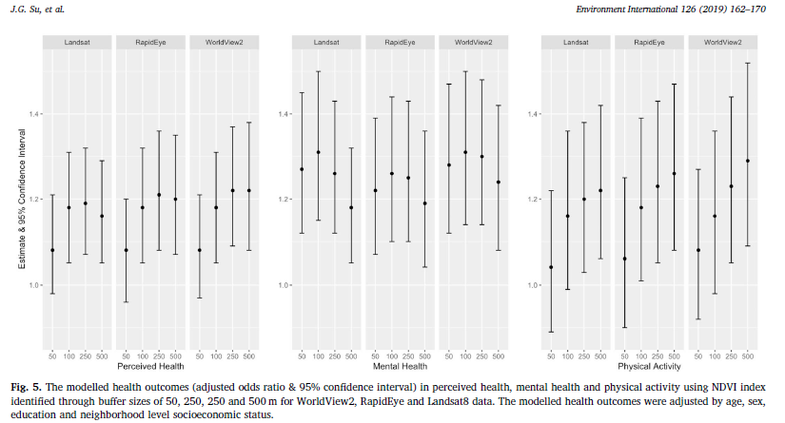

1. **In Figure 5, Su et al. as you increase buffer size for green space, what happens to the measure of association between green space (as measured by NDVI index using Worldview2 data) and physical activity? Select one of the follow options.**

It increases

**It stays the same**

**It decreases**

**It increases**

**It is not clear from the forest plot**

1. **Is Figure 5, Su et. al , is the pattern of results the same if you use Rapid Eye or Landsat data? Do the different sources of data for NDVI (WorldView 2, RapidEye, and Landsat) data seem to make a difference in the pattern of associations between green space and health outcomes? Select one of the following four options:**

Yes, the pattern of results is the same when researchers used Rapid Eye or Landsat data.

**Yes, the pattern of results is the same when researchers used Rapid Eye or Landsat data.**

**No, the pattern of results is different when researched used Rapid Eye or Landsat data.**

**You can’t tell if the pattern is similar or different when looking at these alternate data sources.**

**Only on alternate Thursdays**

1. **What kind of systematic error does this describe? “Willingness to participate is related to both exposure and case-control status. Healthy controls were more likely to participate then cases with brain cancer. Those who did not use cell phones were less likely to participate than cell phone users. The prevalence of cell phone use was over estimated among controls. The measure of association was bias towards the null. “**

Selection Bias

1. **In Armas Rojas et al 2019, Figure 3, if you only had sufficient funds to create and disseminate a hypertension intervention for one of the 6 age/sex groups, which group would you choose and which piece of evidence would you use to prioritize that one group?**

35-59 female since they have the highest RR

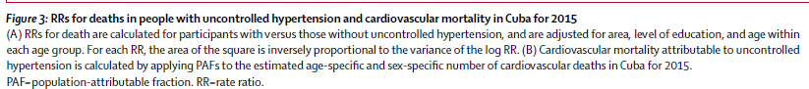

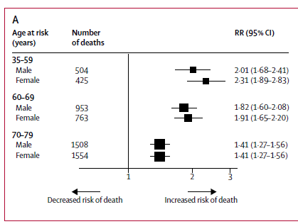

1. **In Sabapathy et. al 2018, Figure 2 is designed to potentially address what kind of bias for the reader?**

Non-response bias

1. **Using Table 1 and adjusted ORs and 95%CIs for your interpretations, were those who refused homebased** **HIV testing kits notably different from those accepted kits?**

Greater than or equal to 4 years in the community was the only significant factor given that the null value 1 is not in the confidence interval

OR 2.09 CI 1.31–3.32

1. **Interpret the adjusted odds ratio and 95%CI that were calculated for “Many people I know had tested with a CHiP so I wanted to as well” in Table 3, “Participants’ perceptions of advantages and disadvantages of accepting of HB-HTC.”**

The odds of being a non-acceptor is .49 times as likely for those who said yes to that question. The CI tells us that 95% of the time, when we calculate a confidence interval in this way, the true adjusted odds ratio will be between .31 and .77.

1. **If you were involved with designing a community focused educational intervention to improve acceptance of the homebased HIV testing in this community, which of the factors encouraging testing would you prioritize, based on results found in Table 3?**

Convenience of having an HIV test at home encouraged me to test since it has the lowest odds ratio, thus indicates the lowest odds of being a non-acceptor.